Multi-Dimensional Lists/Collections
Remember collection variables don’t just have to store basic variables like strings or numbers. Lists can hold much more complex variables including objects, which we’ve just learned about in JavaScript, functions and other lists/tuples/dictionaries. A list that holds other lists is what we refer to as a multi-dimensional list.
Technically there’s no limit to how many lists can be inside lists can be inside lists can be inside lists. However, the most common one you’d come across is called a 2-dimensional list which consists of a list holding lists. Think of the trunk of a car (1 list) holding a bunch of shopping bags (other lists) which each contain shopping items (elements inside list).
bagList1 = [ "Meat", "Fish", "Eggs" ] # list containing strings
bagList2 = [ "Apple", "Orange", "Banana" ]
bagList3 = [ "Milk", "Water", "Juice" ]

carTrunkList = [ bagList1, bagList2, bagList3 ] # 2-dimensional List

Notice how the elements inside carTrunkList don’t have inverted commas ( "" ) around them. That’s because they are variable names which are actual lists.
The above code can be written another way if we simply create the lists inside the holder list.
carTrunkList = [
[ "Meat", "Fish", "Eggs" ] ,
[ "Apple", "Orange", "Banana" ] ,
[ "Milk", "Water", "Juice" ]
]

Notice that we still need to use commas ( , ) to separate each list. All of it must be enclosed inside square brackets [ ].

This 2-dimensional list called carTrunkList will look something like this:

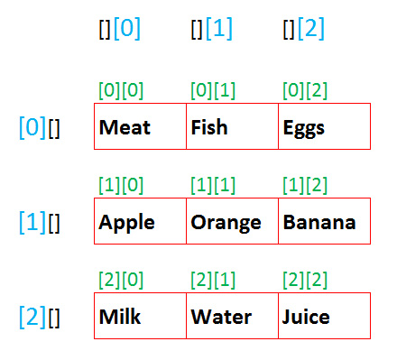

To access the elements inside this list we must again use the [] square brackets and use the corresponding indexed position. Since it is a 2-dimensional list we must use two sets of square brackets [][] when referring to the list.

carTrunkList[ 0 ][ 0 ] # The selected element is “Meat”
carTrunkList[ 1 ][ 1 ] # The selected element is “Orange”
carTrunkList[ 2 ][ 2 ] # The selected element is “Juice”
carTrunkList[ 1 ][ 2 ] # The selected element is “Banana”

In the above example, the first square brackets refer to the list you want to access. In this case we’re getting the first list which contains ["Meat", "Fish", "Eggs"]. The second set of square brackets refers to the specific element inside this list. Since it is 0, we are getting the first element which is "Meat".

Looping Through Multi-Dimensional Lists
At this stage you’re very familiar with using a for loop to loop through all the elements in a list. For multi-dimensional lists you need to nest a for loop inside a for loop to get access to all elements.

for groceryList in carTrunkList:
for groceryItem in groceryList:
print( groceryItem )

